RHYBUDD O RAS – - NOTICE OF RACE
& Entry Form

Pwllheli Regatta Weekend

Racing For IRC and National Handicap for Cruisers NHC.

Date | Number of Races | Warning Signal
Saturday 15th July 2017 | One Bay Race | 1300
Sunday 16th July 2017 | 3 Short Round the Cans Races | 1145

CHPSC Bridge Start and Finish.
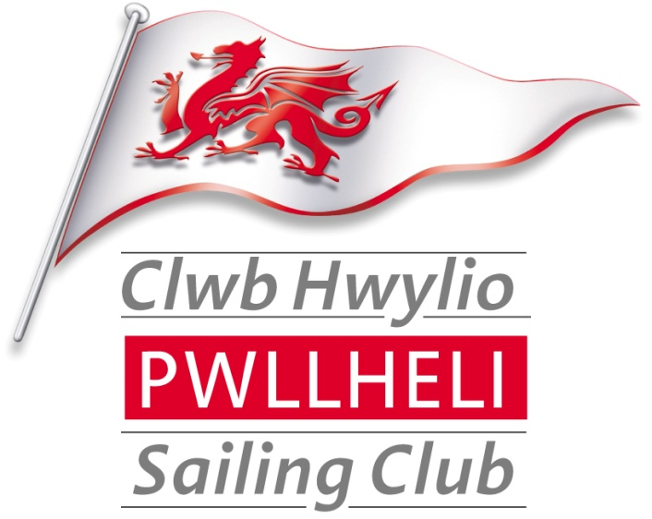
Notice of Race, Entry Form and Race Pack
All available on http://www.pwllhelisailingclub.co.uk/
(See CHPSC Race Pack for Sailing Instructions, Courses and Chart).
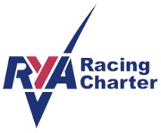
This is an Open Event - all competitors and their crews (guests) will become temporary members of CHPSC for the duration of the event. (Subject to 3.5 below)
On Line Results by Sailwave

2017 Regatta Weekend Series

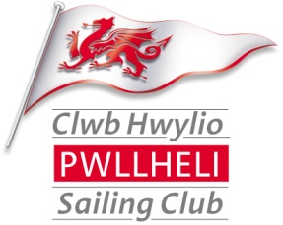
Notice of Race & Entry Form
Organisation.
  - The 2017 Pwllheli Ragatta Weekend is organised by Clwb Hwylio Pwllheli Sailing Club (CHPSC).
  - Enquiries, correspondence and entries should be sent to:-
  - The Sailing Committee, Clwb Hwylio Pwllheli Sailing Club, Glan y Don, Pwllheli, LL53 5YT
  - Tel: Vicky Cox (07710537028) or Stephen Tudor 07977929116 e-mail racing@pwllhelisailingclub.co.uk
Rules.
  - The Racing will be governed by the ‘rules’ as defined in The Racing Rules of Sailing (RRS) and the Clwb Hwylio Pwllheli Sailing Club’s Sailing Instructions 2017.
  - IRC rules part A, B & C shall apply to IRC racing.
  - Handicapping by RYA National Handicap for Cruisers (NHC) Club series shall apply.
  - In the event of conflict, the CHPSC 2017 Sailing Instructions will prevail. This changes RRS 63.7
RYA Racing Charter
  - Clwb Hwylio Pwllheli Sailing Club implements the RYA Racing Charter which requires both competitors to sail, and organisers to provide, racing in compliance with the Charter, which can be found at the front of the RYA rule book (Racing Rules of Sailing) or at www.rya.org.uk/racing/charter.
Entries, Registration & Eligibility
  - 2017 Regatta Weekend Series is an open event and entries are invited from CHPSC members and non-members.
  - Competitors must complete the entry form and pay the race fee to CHPSC or by using the Annual Entry Form here
  - The 2017 Regatta Weekend Series will provide racing for the following classes of yachts and the Class divisions will be as follows: -
Class | Flag | IRC – NHC Club
One | numeral pennant 1 (White with Red spot) | All boats
  - These ranges may be changed at the discretion of the sailing committee
  - Class Flags may be flown from the backstay of each competing yacht.
  - Yachts shall belong to or be chartered to and be under the control of a member of a yacht club affiliated to the RYA or other equivalent national authority.
  - Entries shall be made on the Official Entry Form which is attached to this Notice of Race and this should be posted in the official race entry box located next to the official Notice Board in the entrance hallway of CHPSC.
  - The entry form must be accompanied with the appropriate entry fee and for IRC entries a copy of a valid IRC Certificate.
  - Entries will, in exceptional circumstances, be accepted, at the Race Officers discretion, by VHF for yachts arriving from other clubs.
  - The Race Committee reserves the right to refuse any entry and/or to ask any boats to complete further undertaking or declarations before accepting their entry.
  - Registration can be done at the CHPSC club room. Race packs are available for printing from the CHPSC web page.
Measurement
  - For IRC competitors a valid and current IRC rating certificates must be presented with the race entry form.
  - The race series will be dual scored using the IRC and NHC Handicapping by RYA National Handicap for Cruisers (NHC). This is to encourage boats that do not hold a valid IRC certificate to race.
Changes in Sailing Instructions
  - Any change to Sailing Instructions will be posted by 08.30hrs on the day it will take effect and may be repeated on the Clwb Hwylio Pwllheli Sailing Club Web Page.
Schedule of Races.
  - The race schedule will be as shown on the front page of this Notice of Race. The Race Officer will decide if there is to be one start for all classes or separate starts for each class or a group of classes. This will be announced by VHF (Channel 17) and flags.
  - The type of racing will be a long bay race and the course will be announced by the Race Officer and will be based on the schedule of marks provided in the CHPSC 2017 Race Pack available on the CHPSC web page.
The racing
  - The race will be in accordance with the General Sailing Instructions here
Time of Starts
  - To be announced
  - The start may be broadcast on VHF Channel 17
Risk Statement
  - RRS Rule 4 of the Racing Rules of Sailing states: “The responsibility for a boat’s decision to participate in a race or to continue racing is hers alone.”
  - Sailing is by its nature an unpredictable sport and therefore inherently involves an element of risk. By taking part in the event, each competitor agrees and acknowledges that:
(a) They are aware of the inherent element of risk involved in the sport and accept responsibility for the exposure of themselves, their crew and their boat to such inherent risk whilst taking part in the event;
(b) They are responsible for the safety of themselves, their crew, their boat and their other property whether afloat or ashore;
(c) They accept responsibility for any injury, damage or loss to the extent caused by their own actions or omission;
(d) Their boat is in good order, equipped to sail in the event and they are fit to participate;
(e) The provision of a race management team, patrol boats and other officials and volunteers by the event organiser does not relieve them of their own responsibilities;
(f) The provision of patrol boat cover is limited to such assistance, particularly in extreme weather conditions, as can be practically provided in the circumstances;
(g) They are responsible for ensuring that their boat is equipped and seaworthy so as to be able to face extremes of weather; that there is crew sufficient in number, experience and fitness to withstand such weather; and that the safety equipment is properly maintained, stowed and in date and is familiar to the crew.
(h) Their boat is adequately insured, with cover of at least £3,000,000 against third party claims.
Safety
  - All yachts shall comply with ISAF offshore safety regulations Category 4.
Personal Safety
RRS 1.2, 40 shall apply and it is the sole responsibility of the skipper to ensure that Life Jackets/Harness lines are carried for each member of the crew.
Clwb Hwylio Pwllheli Sailing Club
The 2017 Pwllheli Regatta Weekend Series
Racing Entry Form
Owner |  |  |  |  | Yacht
Owner/Skipper name |  |  |  |  | Yacht Name
Address |  |  |  |  | Sail Number
IRC Rating TCC….(No.)
See note below if no valid Cert available
 |  |  |  |  | NHC (base number – this will be provided by the Race Committee)
 |  |  |  |  | Type / Class of Yacht
Postcode |  |  |  |  | Designer
Telephone – Day |  |  |  |  | LOA
Telephone – Evening |  |  |  |  | Colour of hull
Mobile No. |  |  |  |  | Club…………………………………………………………….  Non members - please state which RYA Affiliated Club represented
Please provide email address
Class Entered  Tick box | IRC | NHC |  |  | Enclosed Copy of current Certificate  Tick box |  |  | IRC
Series |  |  | £ | Tick box |  | Certificate/Payment |  |  | Tick box
For the Series |  |  | £15 |  |  | I enclose a copy of my current Rating Certificate
 |  |  |  |  |  | I do not have a valid IRC certificate and I would be obliged if the Race Committee would score the series using NHC (club)
NB you can enter the for all CHPSC races for £50 (subject to conditions) |  |  |  | I enclose £……………………….in entry fees  (cheques payable to Pwllheli Sailing Club)
 |  |  |  | I have paid at the Club Bar with my Club Card Receipt attached
Declaration
Adequate third party insurance is held with respect to this yacht. The yacht is fully equipped with safety equipment in accordance with its class requirement.
I hereby agree to be bound by the Racing Rules of Sailing (RRS) that govern this regatta. I confirm that I have read the Notice of Race and accept its provisions and agree that my boat will conform to the requirements set out in the Notice of Race throughout the event
I hereby indemnify Clwb Hwylio Pwllheli Sailing Club and the Sailing Committee against all claims whatsoever arising from my yachts participation in these races.
I agree to allow any photographs taken during the event to be used by CHPSC for promotional purposes.
Signature……………………………………………….… |  |  |  |  |  |  | Date……………………………………………….…….
YACHT THAT HAVE NOT PAID THEIR RACING FEES WILL NOT QUALIFY AS STARTERS
Clwb Hwylio Pwllheli Sailing Club, Glan Y Don, Pwllheli, Gwynedd LL53 5YT
racing@pwllhelisailingclub.co.uk www.pwllhelisailingclub.co.uk
Office 01758 613343 Bar / Clubroom 01758 614442

